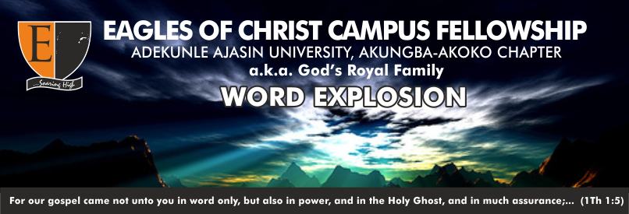

**THEME: THE SPIRIT OF GOD TEL: 09037309053**

**TOPIC: PUTTING YOUR TOTAL TRUST IN GOD 07038507050**

**TEXT: PSALM 118:8-9**

**TEACHER: SIS. BIOLA**

**DATE: 27TH AUGUST, 2019. Email: eccfaaua@yahoo.com**

**Golden Text: Psalm 56:11**

T

he Lord who has brought us together to learn at his feet, may His name alone be highly lifted up. Amen. Today, God will be teaching us to put our total trust in Him.

**Trust** means having confidence or reliance on someone or something ***(Ps. 20:7 NIV).*** Trusting in God is a cogent and essential heed in the life of God’s children. Putting our total trust in God is seen as the strength of a believer ***(Ps. 125:1).***

As we have established earlier that, trust means having confidence in someone, there’s need for us to put our absolute trust in God ***(Prov. 3:5).*** A man who puts his total trust in God is declared blessed ***(Ps. 40:4),*** and I can only put my trust in God by believing in Him. Many actually trust in God, but not with their totality.

**Practical Discussions**

* Why must I put my total trust in God? ***Ps. 118:8.***
* What level of trust should we have in God? ***Pro. 3:5***
* How can I put my trust in God?
* Can we say that trust is faith?

As we have learnt today, it is essential for us as kingdom dwellers to put our trust; not partial or little but total and absolute trust in God.

**Hymn**

**TRUST AND OBEY**

1. **When we walk with the Lord in the light of His Word,  
   What a glory He sheds on our way!  
   While we do His good will, He abides with us still,  
   And with all who will trust and obey.**

***Refrain:  
Trust and obey, for there’s no other way  
To be happy in Jesus, but to trust and obey.***

1. **Not a shadow can rise, not a cloud in the skies,  
   But His smile quickly drives it away;  
   Not a doubt or a fear, not a sigh or a tear,  
   Can abide while we trust and obey.**
2. **Not a burden we bear, not a sorrow we share,  
   But our toil He doth richly repay;  
   Not a grief or a loss, not a frown or a cross,  
   But is blessed if we trust and obey.**
3. **But we never can prove the delights of His love  
   Until all on the altar we lay;  
   For the favor He shows, for the joy He bestows,  
   Are for them who will trust and obey.**
4. **Then in fellowship sweet we will sit at His feet,  
   Or we’ll walk by His side in the way;  
   What He says we will do, where He sends we will go;  
   Never fear, only trust and obey.**

***ALL CORRESPONDENCE TO THE BIBLE STUDY UNIT VIA THE SECRETARY***